



Mechanical Shaft
Shaft Assembly Project
Project Report
DATE:
January 25, 2026
Submitted By:
Frais Asghar
CMS ID: 516900
ME-16(Section-A)

Shaft Assembly Project

1. Project Overview
This project involves comprehensive CAD modeling and technical analysis of a stepped mechanical shaft and its integrated support bracket. The design was executed to meet specific geometric constraints and engineering standards, focusing on functional assembly and structural integrity.

2. Objectives
The primary objectives of this design project were:
- Precision Modeling: To develop a high-fidelity 3D model of a mechanical shaft with varying diameters and stepped sections.
- Technical Interpretation: To accurately translate complex orthographic dimensions into a 3D isometric representation.
- Design for Assembly (DFA): To ensure proper tolerance and alignment between the shaft and the green support housing.
- Geometric Fidelity: To apply specific radii (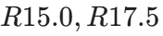) and hole diameters () as dictated by engineering specifications.

3. Component Analysis

3.1 Stepped Mechanical Shaft
The shaft is the primary rotating or load-bearing element. It features:
- Flange Section: A  mounting flange that interfaces with the support bracket.
- Transition Zones: Smooth transitions between sections to reduce stress concentration.
- Keyed/D-Cut Profile: A functional end section with an  radius and a 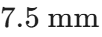 offset flat surface, designed for torque transmission or specific orientation.
- Dimensional Accuracy: Total functional length measured at 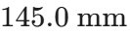, with sub-sections of 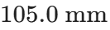 and 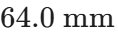.

3.2 Support Bracket
The green support component serves as the stationary base:
- Hole Geometry: Includes two  mounting holes positioned with a 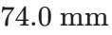 span.
- Structural Support: Features a 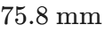 height with a central bore to accommodate the 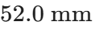 hexagonal/rounded interface of the shaft.

4. Technical Specifications
Feature | Dimension (mm)
Main Flange Diameter
Support Hole Spacing |  (Center-to-Center)
Shaft Total Length | 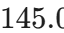
Support Height | 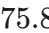
End Radius
Flat Surface Offset | 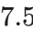

5. Design Methodology
The development process was conducted through the following stages:
- Drafting & Sketching: Initial 2D profiles were created for the support bracket and the shaft cross-sections.
- Extrusion & Revolution: The bracket was created via linear extrusion, while the shaft utilized both revolutionary and additive extrusion techniques.
- Refinement: Fillets and radii (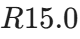 on the bracket corners) were applied to ensure ergonomic handling and mechanical durability.
- Verification: A final check of the 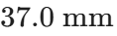, 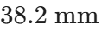, and 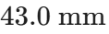 clearance dimensions was performed to confirm assembly fitment.

6. Engineering Considerations
- Stress Distribution: Use of rounded corners on the support bracket to prevent cracking under vibration.
- Manufacturability: The shaft design is optimized for lathe operations followed by a milling process for the flat end section.
- Material Efficiency: Geometry suggests a balance between weight reduction and torsional rigidity.

7. Conclusion
This project successfully demonstrated the application of advanced CAD modeling techniques to solve mechanical design challenges. By strictly adhering to the 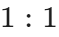 dimensional requirements, the resulting model serves as a production-ready representation of a mechanical assembly. This experience has significantly strengthened my proficiency in SolidWorks/AutoCAD and my understanding of real-world mechanical tolerances.

